**PHYSICS**

**YEAR 12**

**Unit 3 2016**

**2015**

Rossmoyne Senior High School

Name: \_\_\_\_\_\_\_\_\_\_\_\_\_\_\_\_\_\_\_\_\_\_\_\_\_\_\_\_\_\_\_\_\_\_\_\_\_\_\_\_\_\_\_\_\_\_\_\_\_\_\_\_\_\_\_

Teacher: \_\_\_\_\_\_\_\_\_\_\_\_\_\_\_\_\_\_\_\_\_\_\_\_\_\_\_\_\_\_\_\_\_\_\_\_\_\_\_\_\_\_\_\_\_\_\_\_\_\_\_

***TIME ALLOWED FOR THIS PAPER***

Reading time before commencing work: Ten minutes

Working time for the paper: Three hours

***MATERIALS REQUIRED/RECOMMENDED FOR THIS PAPER***

**To be provided by the supervisor:**

* This Question/Answer Booklet; ATAR Physics Formulae and Data Booklet

**To be provided by the candidate:**

* Standard items: pens, pencils, eraser or correction fluid, ruler, highlighter.
* Special items: Calculators satisfying the conditions set by the SCSA for this subject.

***IMPORTANT NOTE TO CANDIDATES***

No other items may be taken into the examination room. It is **your** responsibility to ensure that you do not have any unauthorised notes or other items of a non-personal nature in the examination room. If you have any unauthorised material with you, hand it to the supervisor **before** reading any further.

**Structure of this paper**

|  |  |  |  |  |  |
| --- | --- | --- | --- | --- | --- |
| Section | Number of questions available | Number of questions to be answered | Suggested working time  (minutes) | Marks available | Percentage of exam |
| Section One:  Short answer | 10 | 10 | 50 | 54 | 30 |
| Section Two:  Extended answer | 7 | 7 | 90 | 90 | 50 |
| Section Three:  Comprehension  and data analysis | 2 | 2 | 40 | 36 | 20 |
|  |  |  | **Total** | 180 | 100 |

**Instructions to candidates**

1. The rules for the conduct of Western Australian external examinations are detailed in the *Year 12 Information Handbook 2016.* Sitting this examination implies that you agree to abide by these rules.
2. Write answers in this Question/Answer Booklet.
3. When calculating numerical answers, show your working or reasoning clearly. Give final answers to **three** significant figures and include appropriate units where applicable.

When estimating numerical answers, show your working or reasoning clearly. Give final answers to a maximum of **two** significant figures and include appropriate units where applicable.

1. You must be careful to confine your responses to the specific questions asked and follow any instructions that are specific to a particular question.
2. Spare pages are included at the end of this booklet. They can be used for planning your responses and/or as additional space if required to continue an answer.
   * Planning: If you use the spare pages for planning, indicate this clearly.
   * Continuing an answer: If you need to use the space to continue an answer, indicate in the original answer space where the answer is continued, i.e. give the page number. Refer to the question(s) where you are continuing your work.

**Section One: Short response 30% (54 marks)**

This section has **ten** **(10)** questions. Answer **all** questions. Write your answers in the space provided.

When calculating numerical answers, show your working or reasoning clearly.

Give final answers to three significant figures and include appropriate units where applicable.

When estimating numerical answers, show your working or reasoning clearly. Give final answers to a maximum of two significant figures and include appropriate units where applicable.

Spare pages are included at the end of this booklet. They can be used for planning your responses and/or as additional space if required to continue an answer.

● Planning: If you use the spare pages for planning, indicate this clearly at the top of the page.

● ontinuing an answer: If you need to use the space to continue an answer, indicate in the original answer space where the answer is continued, i.e. give the page number. Fill in the number of the question that you are continuing to answer at the top of the page

Suggested working time for this section is 50 minutes.

1. **(4 marks)**

Kepler’s 3rd law of planetary motion is:

$$T^{2}= \frac{{4π}^{2}}{GM} r^{3}$$

Derive this formula using at least two other equations from the supplied data sheet. Show ALL steps in your working.

1. **(6 marks)**

A spherical, 2.00 kg ball, rests on a plane with a slope of 30.0o as shown in the diagram below.

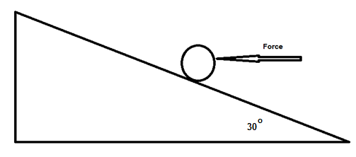

* 1. Calculate the minimum horizontal force that will prevent the ball moving down the frictionless plane. (3 marks)
  2. The horizontal force is removed. Calculate the magnitude of the normal reaction force provided by the plane on the ball. (3 marks)

1. **(8 marks)**

The two parallel wires shown below each has an 8.00 A current flowing; one is into the page while the other is out of the page. The wires are 5.30 cm apart.

* 1. Draw the magnetic field in the space surrounding the two wires. (3 marks)
  2. Calculate the magnitude of the magnetic flux density at a point 1.50 cm from the left wire, towards the right wire. (5 marks)

1. **(7 marks)**

The volume of a hydrogen atom is 1.99 x 10-31 m3. Assume the atom is a sphere and its single electron travels along the surface of the sphere. The single proton is located in the centre of the sphere.

Volume of a sphere

* 1. Calculate the gravitational force acting between the proton and electron. (4 marks)

* 1. Calculate the electromagnetic force acting between the proton and electron. (2 marks)
  2. Calculate the net force acting between the proton and electron. (1 mark)

1. **(4 marks)**

Juliette (43.2 kg) decided to build a seesaw using a 4.12 m uniform beam The fulcrum was placed midway along the beam. She was accompanied by her friend, Ben (55.7 kg) and her sister, Claire (21.6 kg). Ben sits at the maximum distance from the fulcrum. Draw a diagram with the relevant distances and forces shown to help describe where Juliette and Claire could sit so that the seesaw is in equilibrium. Note that Juliette and Claire must sit at different distances from the fulcrum.

1. **(6 marks)**
   1. On the following diagram, draw the magnetic fields. Draw at least ten lines.

(4 marks)

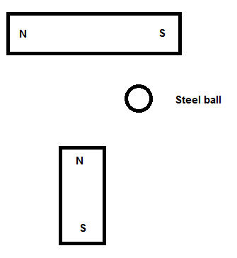

Iron ball

**Question 6 continued**

* 1. Draw the electric fields of the following diagram. Draw at least five lines.

(2 marks)

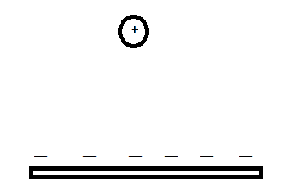

1. **(6 marks)**

A roller coaster with three passengers has a mass of 9.73 x 102 kg. The participants experience being upside down at the top of the circular track of a “loop the loop” showground ride. The centre of mass of the roller coaster and passengers is 15.3 m from the bottom of the ride. It is travelling at a constant speed of 12.3 m s–1.

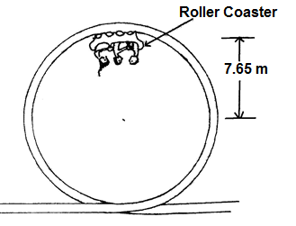

* 1. On the diagram above, draw a vector to indicate the direction of the force of the rail acting on the coaster plus passengers. (1 mark)
  2. Calculate the magnitude of the force that the rails at the top of the ride exerts on the coaster plus passengers. (5 marks)

1. **(4 marks)**

An electric beater is used to make bread dough of the right consistency. During normal operation the beater spins at a high rpm to mix the dough. When the bread dough was too thick, the electric motor jammed and consequently melted. Explain why this happened when the beater was stuck but does not occur when the beater is spinning.

1. **(3 marks)**

The most common form of regenerative braking in a car involves using the car’s electric motor as a source of emf. Explain how this occurs and why this process also helps to slow the car down.

1. **(6 marks)**

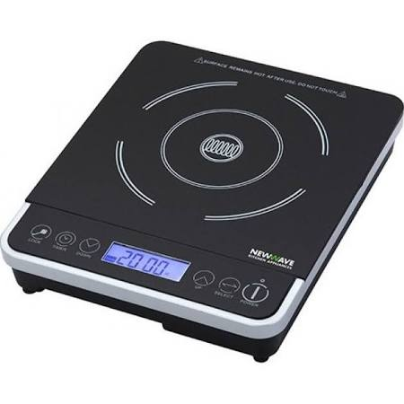The diagram shows a typical hotplate which is common used in households. It can heat water in a saucepan without using flame.

1. Explain how these hotplates can heat water in a saucepan. Include in your answer what material should the saucepan to be made for it to work best. (4 marks)
2. Does the hotplate get hot while the device is on without a saucepan on top? Explain. (2 marks)

**End of Section 1**

**Section Two: Problem-solving 50% (90 Marks)**

This section has **seven (7)** questions. You must answer **all** questions. Write your answers in the space provided.

Spare pages are included at the end of this booklet. They can be used for planning your responses and/or as additional space if required to continue an answer.

● Planning: If you use the spare pages for planning, indicate this clearly at the top of the page.

● Continuing an answer: If you need to use the space to continue an answer, indicate in the original answer space where the answer is continued, i.e. give the page number. Fill in the number of the question that you are continuing to answer at the top of the page.

Suggested working time for this section is 90 minutes.

1. **(12 marks)**

Two 20.0 kg six-year-old children sit next to each other with their shoulders touching.

* 1. **Estimate** the gravitational force between them. (3 marks)
  2. Draw the gravitational field of only one of the children. (Use at least 6 field lines.)

(3 marks)



**Question 11 continued**

* 1. One of these two children is lying on the floor. He climbs on top of a shelf and stands upright. The shelf is one metre above the ground. **Estimate** the work done by the child to reach this position. (Hint: consider where the child's centre of mass is located).

(3 marks)

* 1. The child steps off the shelf. When their centre of mass is 0.700 m above the ground estimate their velocity and kinetic energy.

(3 marks)

1. **(17 marks)**

The Perth Wildcats basketball team is two points down and Nat Jawai has the ball in centre court. He puts up the shot and scores three points.

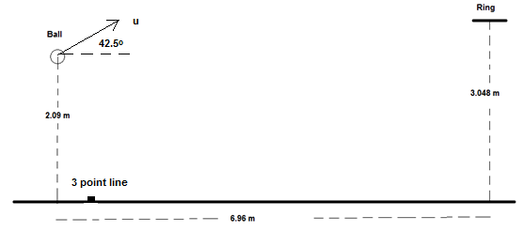

* 1. In the space below, draw a diagram of the ball showing the force/s acting on it whilst in flight. Assume no air resistance and do not add any extra arrows. (2 marks)
  2. He propels the ball at an angle to the horizontal of 42.5o. What is the initial speed of the ball as shown in the diagram? (6 marks)
  3. Calculate the velocity, including direction of the ball, as it passes through the ring in order to score the three points to win the game. If you could not find an answer to part a) you may consider the initial speed of the ball to be 6.50 ms-1. (7 marks)
  4. On the diagram below, draw the path of the ball **with and without** air resistance.

Assume that the basketball is launched with the same initial velocity.

(2 marks)



1. **(11 marks)**

At the centre of the Milky Way is a black hole known as Sagittarius A\*. It has a mass equivalent to 4.31 billion Suns. It is 26 500 light years from the Sun. A light year is the distance light would travel in one year. Light has a velocity of 3.00×108 ms-1.

* 1. Calculate the gravitational force between the black hole and the Sun.

(3 marks)

* 1. Use this force (from part a), to calculate the orbital speed of the Sun as it follows an approximately circular orbit around the black hole. If you cannot determine a value to part (a) you may use 2.00×1019­­ N. (3 marks)
  2. The Sun actually moves around the black hole (assume circular orbit) with a speed of 2.20 x 102 km s-1. Calculate the centripetal force involved in creating this orbit.

(2 marks)

* 1. **Compare** the values of the forces found in part a) and c). Suggest a physical reason for the comparison (**not** simply because the actual speed of the Sun is different to that calculated in part b).

(3 marks)

1. **(15 marks)**

A yacht is moored in a marina being prepared for the Sydney to Hobart race. The uniform boom is 1.50 m above the deck and the negligible mass cable is attached 1.20 m from the end of the boom (boom has a 61.5 kg mass). A 50.0 kg weight is attached at the free end of the boom to prevent sudden movement.

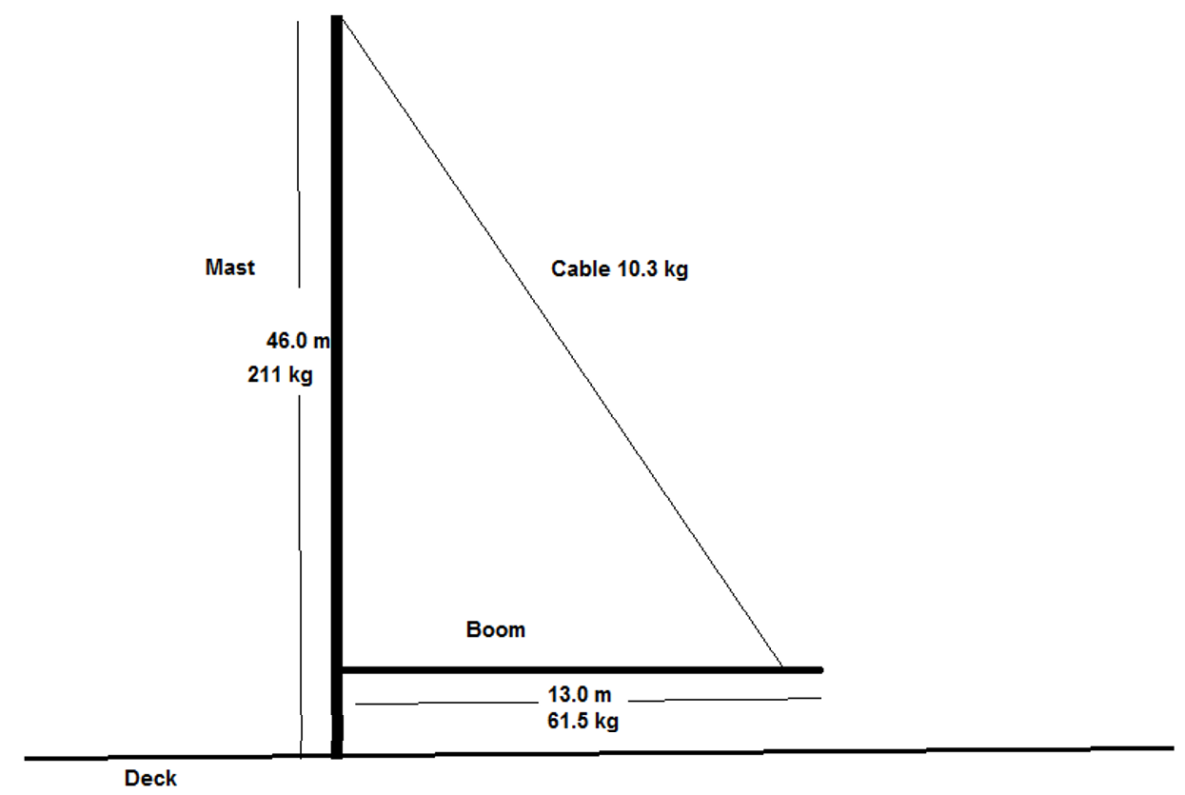

* 1. Draw a free body diagram of the boom in the space below, showing all forces acting on it.

(4 marks)

* 1. Calculate the tension in the cable. (5 marks)
  2. Calculate the reaction force exerted by the mast on the boom. (5 marks)
  3. Describe how the tension in the cable changes when it is attached to the boom at a position closer to the mast. (1 mark)

1. **(17 marks)**

AC and DC generators are important technological devices.

* 1. Using a labelled diagram illustrate how an AC generator creates an AC voltage. Be sure to include an external load, fixed external magnets and any equipment needed to output an AC voltage. A simple 2D diagram is acceptable. Describe how the AC voltage is produced using this equipment. (6 marks)
  2. At which stage of the cycle is maximum emf generated? Explain. (3 marks)
  3. Describe a simple design change that would convert the AC generator into a DC generator. Explain the core function of both pieces of equipment (before and after the design change) in producing the specific type of voltage output.

(5 marks)

* 1. The equation

$${emf}_{rms}= \frac{{emf}_{max}}{\sqrt{2}}$$

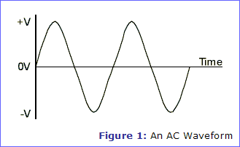is used to calculate the rms emf from the maximum emf in an AC generator. On the graph below, sketch the emfrms based on the voltage profile of the generator. Describe the usefulness of an rms value.

(3 marks)

1. **(13 marks)**

Two parallel charged plates are set up as in the diagram below.

* 1. Draw the electric field between the plates. (3 marks)

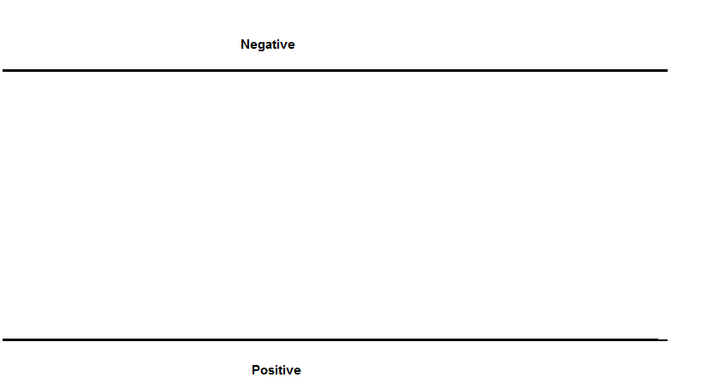

* 1. A proton is fired horizontal, with a velocity of 8.67 x 107 m s-1, into the space between the 0.500 m long plates as shown below. The plates are 20.0 mm apart and the potential difference between the plates is 3.00 x 103 V.

The experiment is placed vertically to the ground so that the negative plate is directly above the positive plate and the proton is affected by gravity.

Calculate the total force acting on the proton as it travels between the plates.

(3 marks)

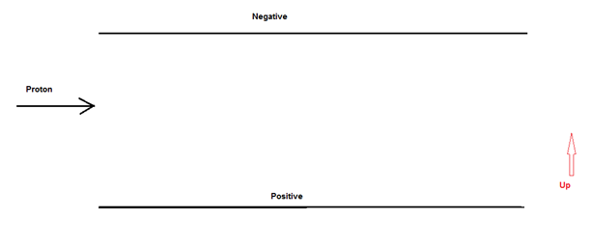

.

* 1. Calculate the speed at which the proton leaves the gap between the plates.

(5 marks)

* 1. Calculate the vertical displacement of the proton whilst it is between the plates.

(2 marks)

1. **(5 marks)**

A truck is being driven around a roundabout, of radius 75.0 m, and it rolls over.

* 1. Explain, referring to centre of mass and a suitable diagram, at which critical point the truck would roll over rather than remain upright. (2 marks)
  2. Road engineers bank roads to help prevent such situations occurring. What angle must the road in part a) be banked to allow the driver to travel through the roundabout, safely, at 18.0 m s-1. At the safe speed the truck corners without relying on friction between the wheels and the road. (3 marks)

**End of Section 2**

**Section Three: Comprehension and Data Analysis 20% (36 Marks)**

This section contains **two (2)** questions. You must answer both questions. Write your answers in the space provided.

Spare pages are included at the end of this booklet. They can be used for planning your responses and/or as additional space if required to continue an answer.

● Planning: If you use the spare pages for planning, indicate this clearly at the top of the page.

● Continuing an answer: If you need to use the space to continue an answer, indicate in the original answer space where the answer is continued, i.e. give the page number. Fill in the number of the question that you are continuing to answer at the top of the page.

Suggested working time for this section is 40 minutes.

1. **Circular Motion (18 marks)**

Many everyday examples rely on circular motion. Satellites for weather observations, GPS, communications and monitoring activities is one such group. Some others include spin dryers in washing machines, separating blood samples into its components in a centrifuge and mass spectrometers.

Centrifugal force does not exist in an inertial frame of reference and is generally considered to be a “mythical” or inertial force. In the past, it was sometimes defined as the reaction force to the centripetal force. Centrifugal is based on the Latin word which means flight (moving away from centre), centripetal comes from the Latin for seeking (moving towards centre).

A satellite orbiting the Earth in a circular orbit is always falling towards the Earth yet maintains the same altitude.

Rockets are used to place satellites in their respective orbits. Satellites that have orbits parallel to Earth’s equator are generally launched in an easterly direction from the east coast close to the equator.

Geostationary satellites are usually launched in this manner. These satellites are a significant reason that we can receive continuous TV signals from the other side of the world. Pay TV companies also use geosynchronous satellites as well as cable to provide services to their customers. They are also valuable in weather services as each satellite monitors a set part of the Earth’s surface.

An experiment to demonstrate the forces involved in circular motion is set up as follows:

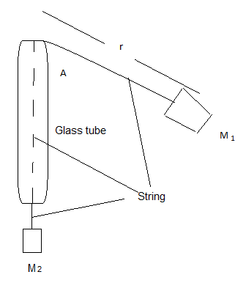

A student holds the glass tube and swings the rubber stopper (M1) in a circle maintaining a constant radius. The force (tension in the string) is provided by the mass (M2). Another student measures the time taken for 25 revolutions.

The following is a set of results for one such experiment.

**M1** has a mass of 38.3 g

**r** is 61.3 cm

|  |  |  |  |
| --- | --- | --- | --- |
| **Force of M2**  **(N)** | **Time for twenty (25) revolutions**  **(s)** | **Period**  **(s)** | **Velocity2**  **(m2 s-2)** |
| 0.50 | 34.1 | 1.36 | 8.0 |
| 1.50 | 19.7 |  |  |
| 2.50 | 15.3 |  |  |
| 3.50 | 12.9 |  |  |
| 4.50 | 11.4 |  |  |
| 5.50 | 10.3 |  |  |

* 1. Complete the two incomplete columns. Assume the string is swung horizontally.

(2 marks)

* 1. Which is the independent variable? (1 mark)
  2. Plot the data for velocity squared against force. (4 marks)

**TITLE: Velocity2 against Force graph**

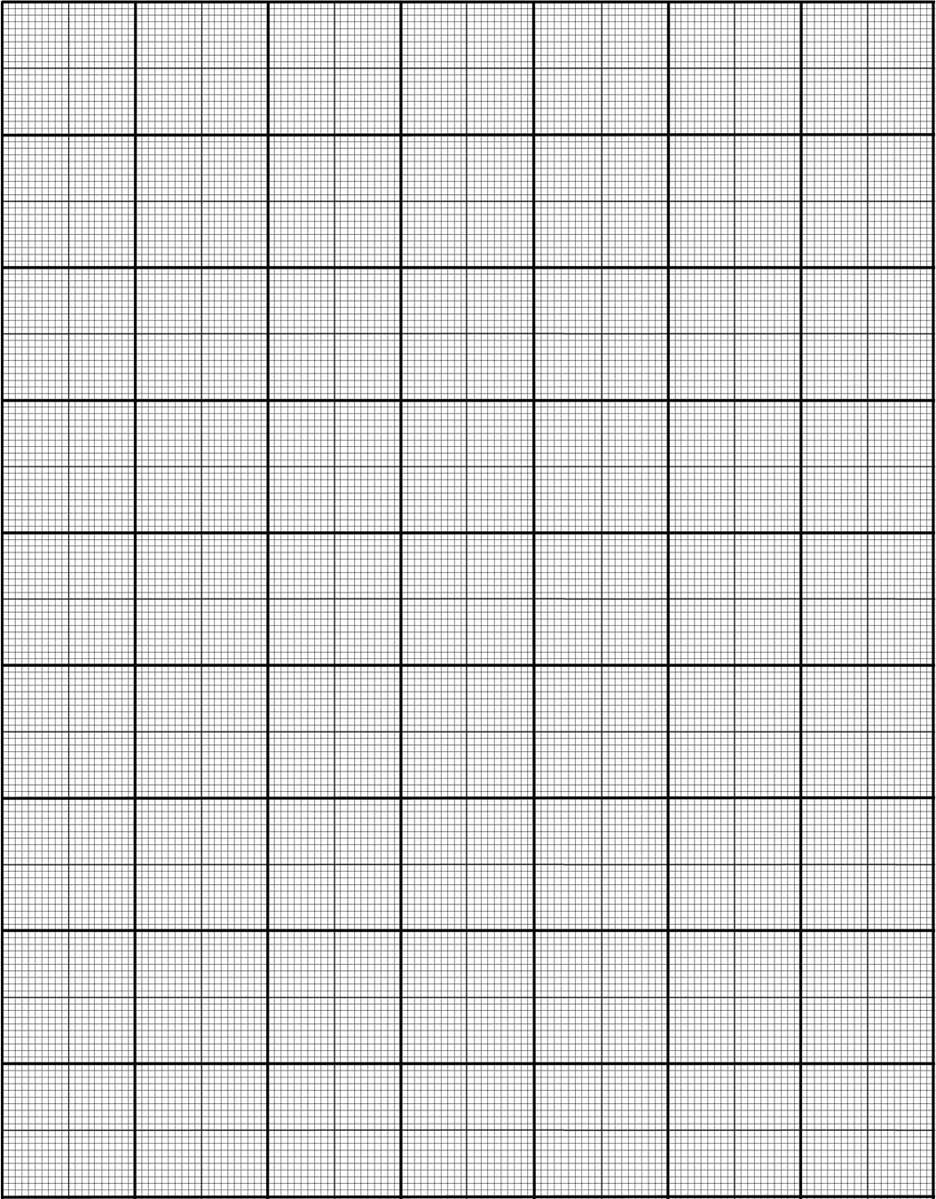

* 1. Find the gradient of the graph. (2 marks)
  2. What physical quantity, **specific to this experiment,** does the gradient of the graph represent? (1 mark)
  3. No matter how fast you can reasonably make M1 travel it will never make the string perfectly horizontal. Explain. (1 mark)
  4. A satellite that is constantly falling can maintain a circular path around the Earth at a constant altitude. Explain why a satellite is constantly falling **and** why the altitude can remain constant. (3 marks)
  5. Explain why, that when a satellite is in a circular orbit around the Earth, the centre of its orbit must be the centre of mass of the Earth. Use diagrams. (3 marks)
  6. Whilst falling, the satellite could be said to be weightless. Explain. (1 marks)

1. **AC/DC: Rock Band or Electricity Wars (18 marks)**

Edison and Tesla, two great scientists found themselves on the opposite sides of the debate whether to use DC (Edison) or AC (Tesla).

Edison to prove his point that AC was too dangerous electrocuted an elephant and advocated that AC be used for the electric chair. Further he built 121 DC power stations in the United States of America. The Boulder power station in the Goldfields of Western Australia was originally a DC power station. Unfortunately, users of this power had to be within 2 km of the station.

AC power could be readily converted from low to high voltages and back again so it could be transferred long distances with lower energy losses.

Much of our electronics today use DC power and when the AC is converted to DC about 3% energy is lost in the form of heat. Also LEDs are designed to use DC and so suffer from flicker on an AC supply which reduces their lives. Solar panels produce DC current which is converted to AC using inverters. DC can now be converted to high voltages relatively easily and voltages for transmission of up to 800 kV have been achieved.

An issue with high voltage AC is the “skin effect” which means that at high voltages the current travels on the outside of the wire which effectively increases the resistance of the wire. This then requires that more expensive multi-strand wires are required to transmit the power. DC systems do not have this issue.

Further many places use UPSs (Uninterruptable Power Supplies) which convert AC to DC (batteries) then back to AC and then back to DC to run the electronics.

Should we convert our power supplies to DC which is safer, much of our electronics use DC already and much of the green energy produced is DC and would be more compatible with a DC grid.

On the reverse many of our appliances are AC based and our power stations are all built to provide AC. Converting them would be a huge expense.

The South/West power grid operated by Western Power extends from Kalbarri (600 km North of Perth) to Ravensthorpe (530 km SE of Perth) across to the coast, with an extension to Kalgoorlie.

Synergy is the electricity generator and retailer for the grid. They charge domestic customers 23.36630 cents per unit. A unit is one kilowatt-hour which is found by multiplying the power consumed in kilowatts by the number of hours the power is used for.

A typical power station can generate 6.00 x 102 MW of energy at 30.0 kV. This is then sent to a sub-station where the voltage is stepped up to 3.30 x 102 kV. This is then transported at that voltage over large distances through a transmission line. It then comes to a series of sub-stations that step down the voltage to 33.0 kV, then 11.0 kV, 6.00 kV and finally about 4.00 x 102 V in Western Australia. Each transformer stage loses approximately 1.00% (ie 99% efficient) and power is also lost through the transmission line.

The three phase power is distributed from the last sub-station as three phase power down the streets. Most houses opt for being supplied with one phase power (~2.40 x 102 V) at a frequency of 50.0 Hz.

Large voltage wires are usually multi-strand aluminium cables surrounding an iron core which provides the tensile strength. The resistance of the wire is 1.02 x 10-4 Ω m-1.

* 1. Explain why multi-strand wires are used in large voltage power lines.

(2 marks)

b) Calculate the energy lost in transmitting 600 MW AC electricity from the power station to the first **step down** sub-station. The step down sub-station is in a town which is 151 km away from the power station. **Do not** include the power lost at the first step down sub-station itself. (7 marks)

c) Calculate the loss over a year in possible revenue that Synergy loses because of this loss of energy. (4 marks)

d) What is the largest transmission voltage used in Western Australia? (1 mark)

e) Explain the cause of the “flicker” in LEDs on an AC supply. (3 marks)

f) Why does DC lose less power in transmission than AC? (1 mark)

**End of Section 3**

**Additional working space**

**Additional working space**

**Additional working space**

**Additional working space**

**Additional graph if required.**

Macintosh HD:Users:wijaya.joni:Desktop:Metric_20mm&2mm_Linear_LightGray&Watermark_MC-Port_Letter.pdf

**End of examination**